**2019 AKAI AMX v1.0.1 - All-In-One Mapping - DJ Estrela March 2019**

**HOW TO DOWNLOAD:** you can ONLY download the mapping if you register and verify your email in the DJTT site!

FEATURE LIST:

* DVS TP3
* 10x shift layers
* Full Transport controls
* Full Tempo controls
* 6x Cues
* 4x Decks
* Loops
* BeatJump
* Preview player
* 5x MixerFX
* 7x MacroFX
* 1x Resonant Filter
* 10x PadFX
* 4x BeatMasher
* 3x UserFX
* Slip Reverse
* 3x Sampler
* Key Adjust
* Filter Roll

LINKS:

* Download Link: <https://maps.djtechtools.com/mappings/9323>
* Documentation: <https://www.facebook.com/pedro.vale.estrela/media_set?set=a.2271291466256713>
* Video demo: <https://www.youtube.com/watch?v=TzAgENM55DE>

DOCUMENTATION INCLUDED:

* Quick start
* Installation guide
* FAQ
* User manual
* Demo Videos

ABOUT THIS MAPPING:

* This is a 2019 mapping for the Akai AMX. This is by far the cheapest and smallest way to unlock both DVS and almost all Traktor Pro 3 functions. In a **single device** you have the equivalent of a Z1+X1+TwisterFighter, at least.
* It is also the most complete by far. It supports 10x layers, 4 decks, full transport and tempo control, TP3 MixerFX, MacroFX, Cues, Loops, beatjump, Rolls, Slip reverse, Sampler, Key adjust, and a Preview Player.
* If you have ANY problems please raise it in the comments section. Do not disrespect the ridiculous time people spend building complex mappings by pressing a thumb down without leaving any steps to reproduce the issue.
* All my mappings are a free gift to the community, to enable DJs to use their preferred Software with their preferred. If you want further appreciation, PayPal donations are welcome ([pedro.estrela@gmail.com](mailto:pedro.estrela@gmail.com))

**Old Summary:**

This is a major rework of the most popular AKAI AMX mapping for Traktor, [originally made by Stewe for TP2](https://maps.djtechtools.com/mappings/4397).

Many thanks for the amazing base work and inspiration!

The biggest additions are MixerFX, MacroFX, Resonant Filter, Filter Roll, Preview player, Slip Reverse and UserFX.

Other features are BeatJump, Full Tempo control, Beatgrid, deck toggle, deck zoom, layout select.

The original mapping from Stewe already included really advanced features like 6x HotCues, 5x PadFX, Loops, a Beatmasher combo, and 4x decks.

To start the mapping, press the MAIN SHIFT button when all lights are “on”.

The below pictures and video explain the mapping functions in great detail.

**Compatibility:**

This mapping was tested in both TP2 and TP3.

The TP3-specific functions are in separate key combinations (to not replace any TP2 functions).

**Installation Instructions:**

VERY IMPORTANT: YOU NEED TO IMPORT THE TSI TWICE FOR THE FX LIST TO BE CORRECT! (this is a Traktor bug)

Please use the big "import" button on the lower left corner of the settings.

Then go to settings / Controller Manager / Device / Select AMX for IN+OUT-PORT. Repeat to all pages of the mapping.

Tutorial on how to import midi mappings in Traktor: https://www.youtube.com/watch?v=6Jw8VyzPrlQ

**V1.0.1 update - July 2019:**

- New feature: reverse crossfader (SH1+CF=No CF; SH2+CF=Normal CF; SH3+CF=Rev CF)

- Fixed beatjump bug (SH2+BRW)

- Fixed Beatmasher combo for right deck (SH1+PN; LD2+SY2+CU2...)

**V1.0.0 Features / demo:** <https://www.youtube.com/watch?v=TzAgENM55DE>

1:11 a 5-minute overview of the most important features (MixerFX, MacroFX, Loops, Multiple shifts, PreviewPlayer, ...)

7:40 How to navigate the Modes using “panel”

8:40 how to install the mapping

10:40 the Main page has 5x shifts

11:26 normal transport functions: Play, Cue, Eq, soft takeover

12:25 Main shift: Master, move to front, slip reverse, zoom, quick search

13:55 Loops

15:10 Beatjump, Loop Move

16:04 Cue Control

16:40 Tempo Control

17:56 Track Search

18:40 Reset Gain, Keylock, Deck 1&3

20:05 Browser, Page up/down, Favorites

21:40 Preview Player lets seek through a track without loading on decks

22:40 MixerFX, MacroFX and Resonant Filter

25:30 shift2 cancels active FX

26:00 PadFX, with 5x subpages

26:30 BeatMasher combo, made by Stewe

26:55 JogFX on browser touch

27:30 Filter Roll on Filter touch

28:00 Key Control

28:40 3x Sampler

29:50 Manual FX (delay T3, Reverb, Flanger)

31:15 Master dry/wet, Pan, Filter resonance

33:15 Change Deck Layout, Number of decks

34:10 Crossfader

34:40 Beatgrid Mode. This can be edited while the other deck is playing

37:30 4-Deck Select

38:20 The manual has a complete reference of all the layers

39:55 DVS support in TP3

40:20 Toggling Fullscreen, Tooltips, etc

**Types of effects:**

|  |  |  |  |
| --- | --- | --- | --- |
| Name | Any page? | Perm? | Description |
| MACRO FX | Yes | Yes | Change to page to select behaviour of Filter button. Press other button to cancel FX |
| PAD FX - 3x Insta | No | No | press LOAD + volume to activate all 3x effects at once. Use shift+Volume to change FX page. |
| PAD FX - Toggle | No | Yes | use buttons to toggle components of 3x effects. Use volume to change parameters |
| HOLD FX | Yes | No | Use secondary shift to select any FX from the list. Use second knob to apply FX with punch-in. Release shift to disable FX. |
| FIXED FX | Yes | Yes | Use main shift to trigger 3x predefined "classic" effects. Use knob to control Dry/Wet. FX stays behind - use Dry to disable |
| JOG FX | Yes | No | Enable touch mode. Touch browser and rotate. Release browsert to stop and restart |

**Layer navigation:**

This is an advanced mapping with multiple layers and multiple shifts. This is crucial to enable so much functionality on such a small device.

Use “Panel” to permanently navigate between pages:

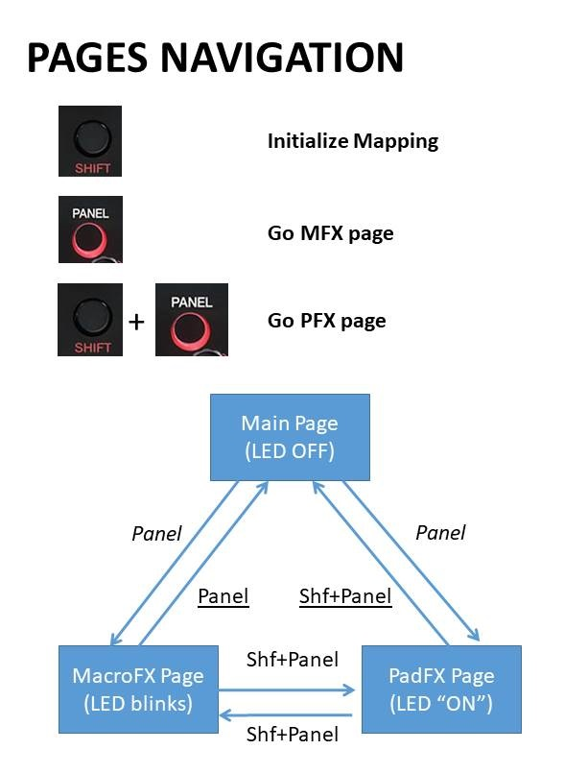

Use the three “shifts” to change the layer inside each page:

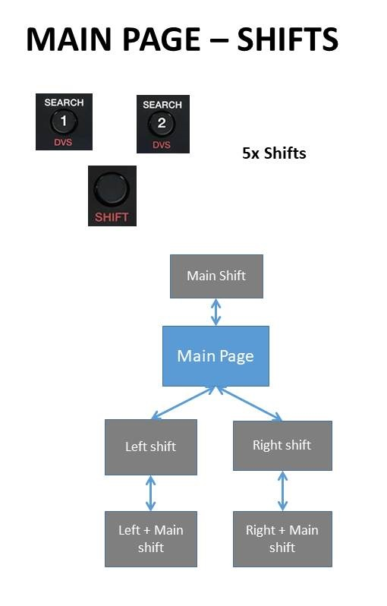

**Quick Reference:**

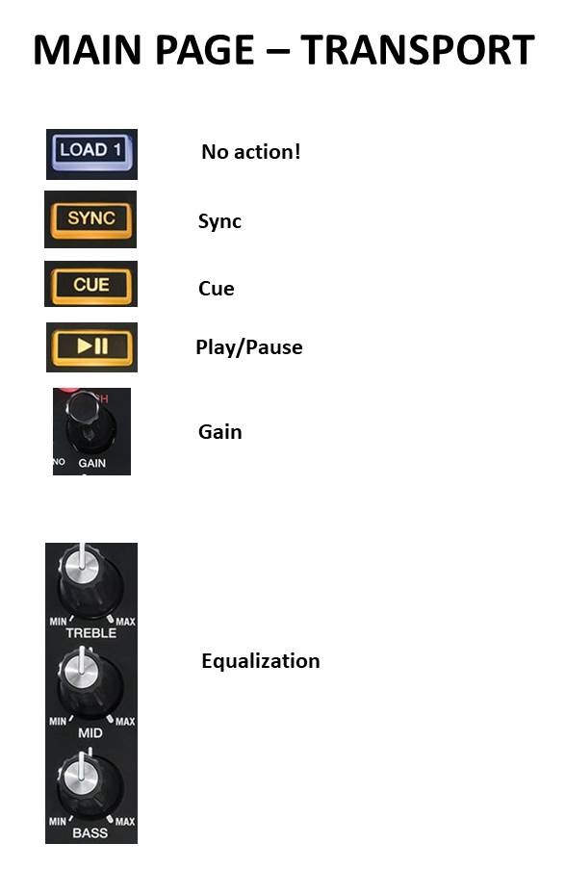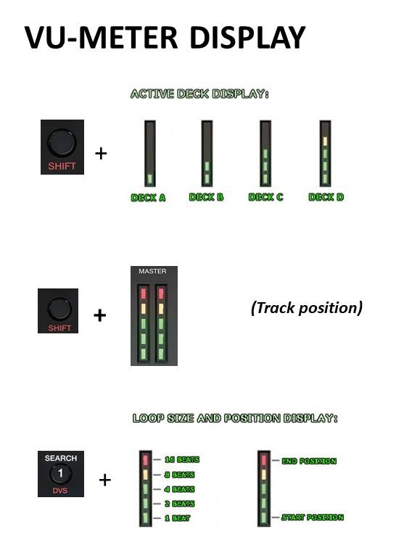

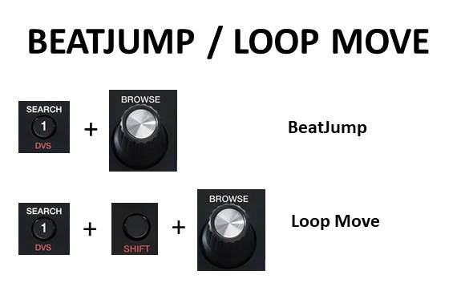 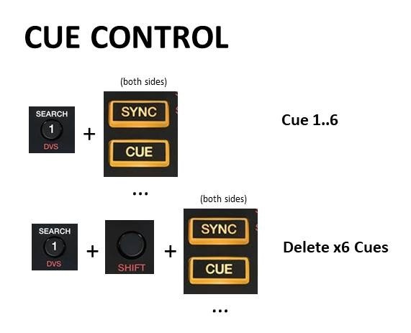

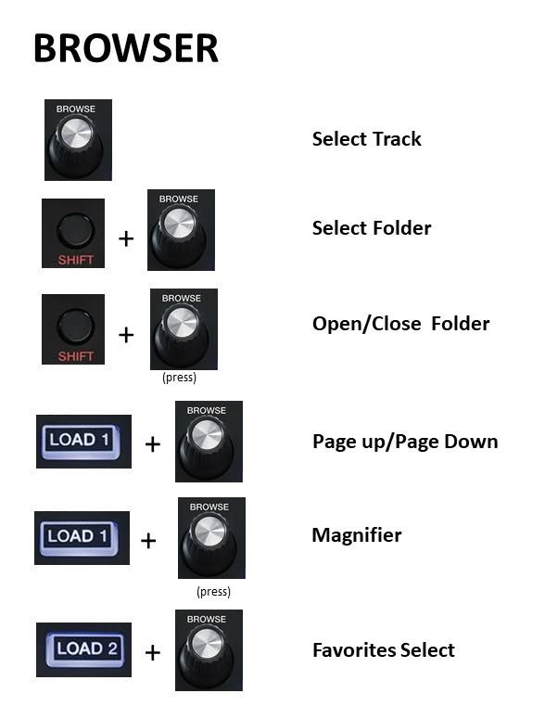

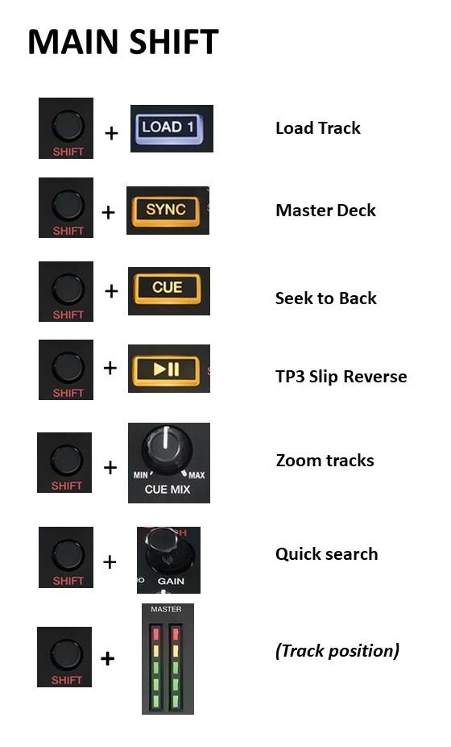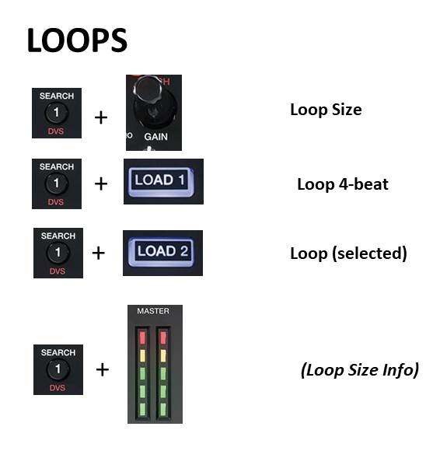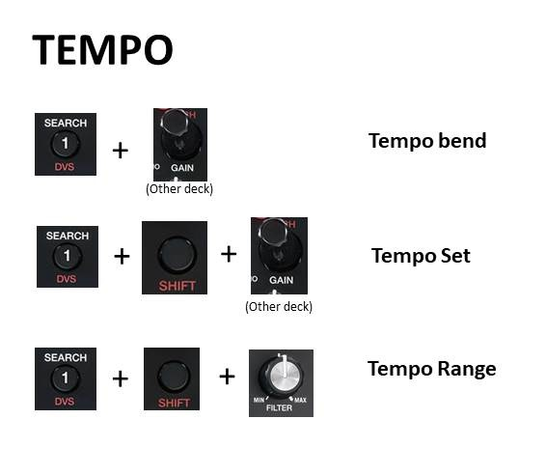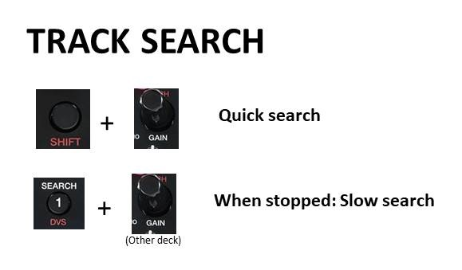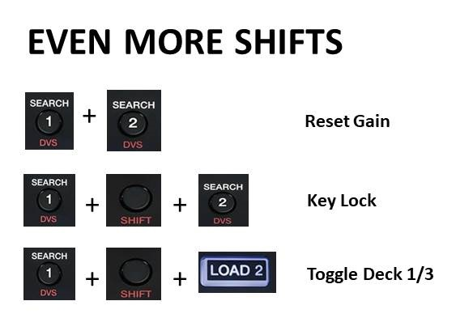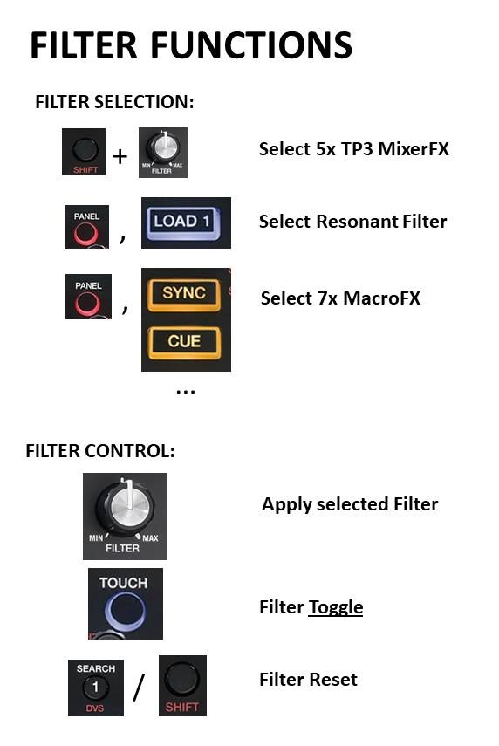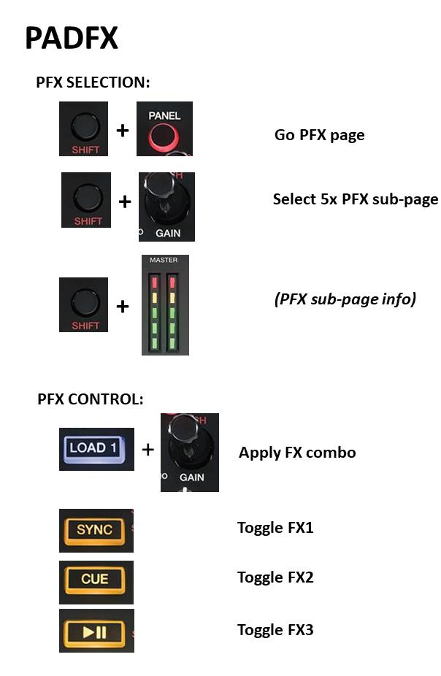

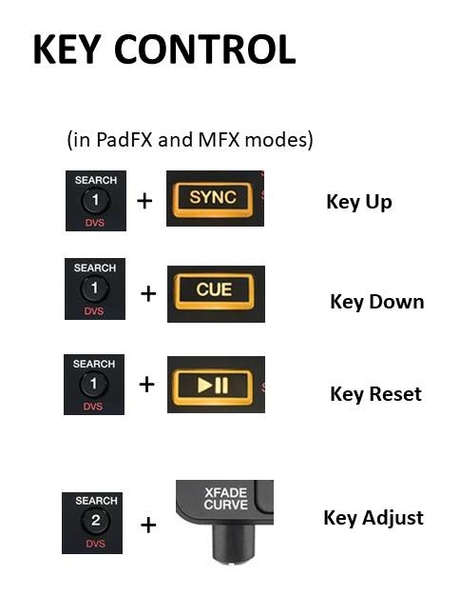 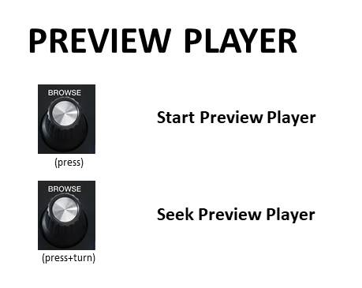

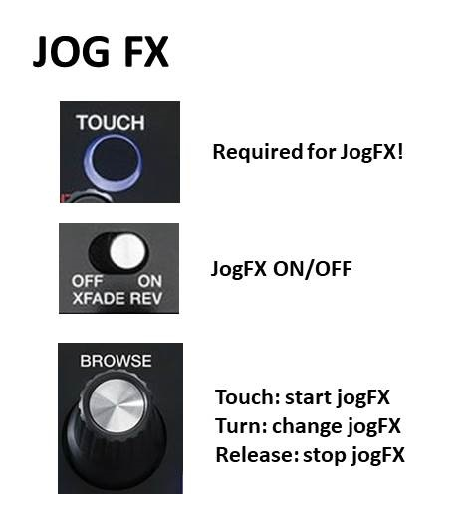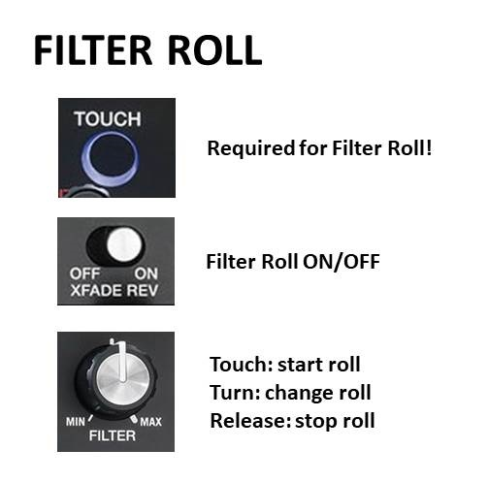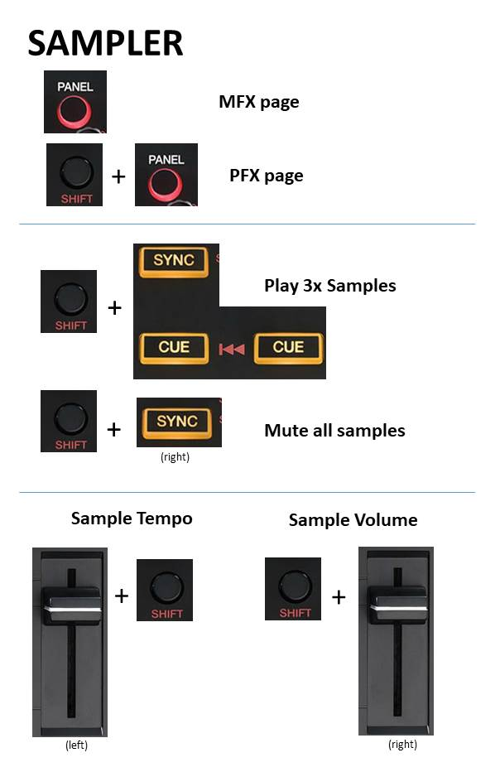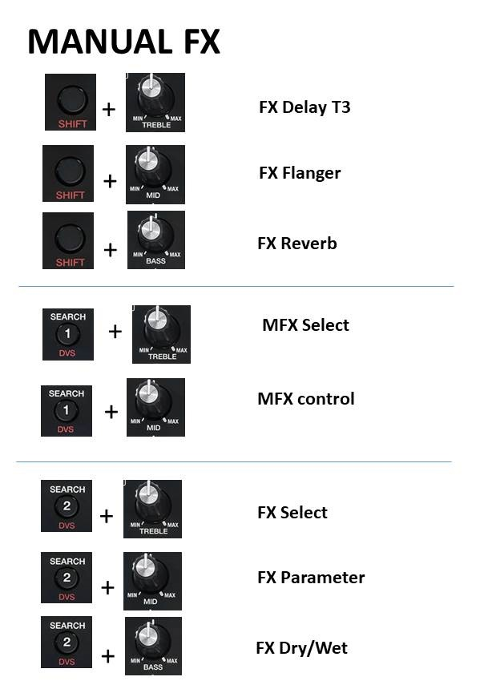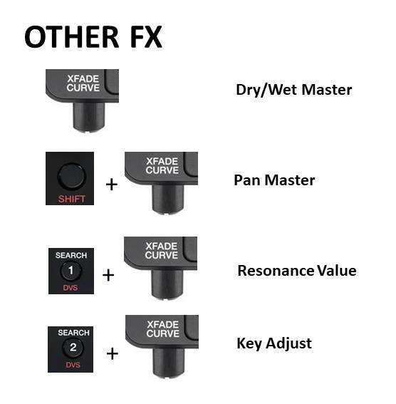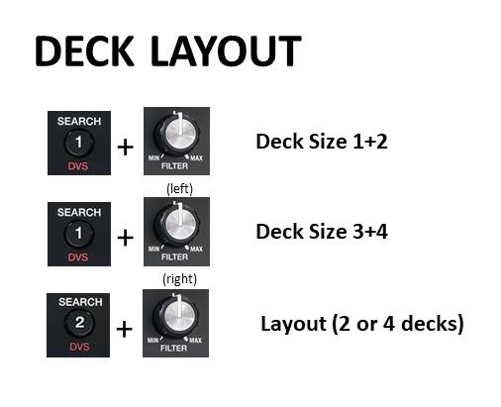

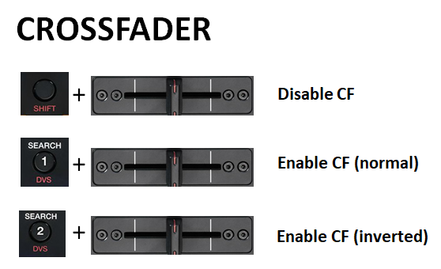

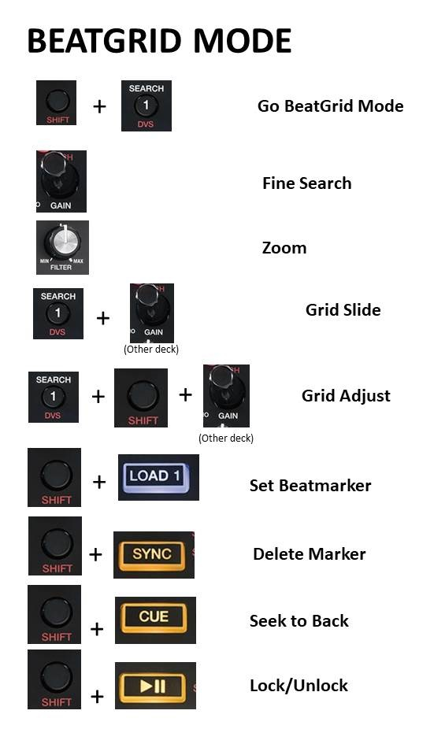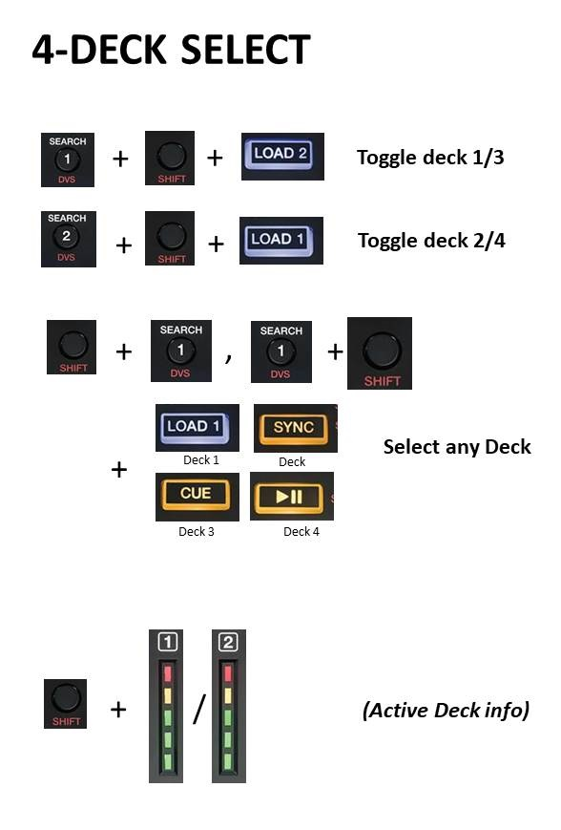

Complete reference:

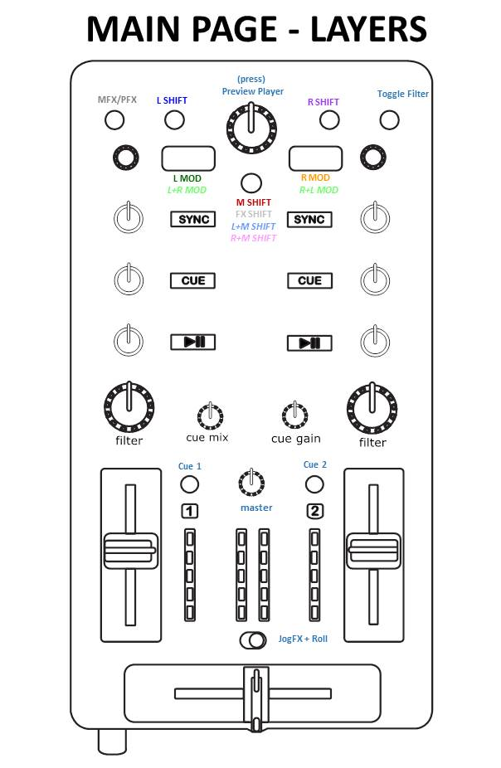

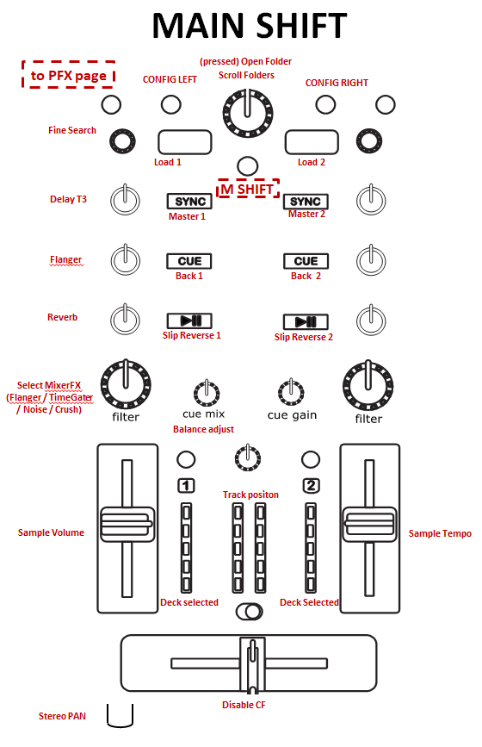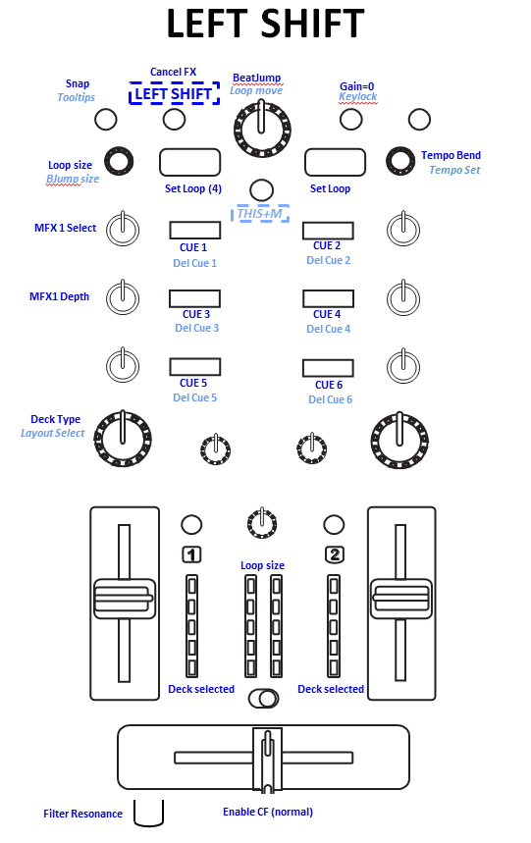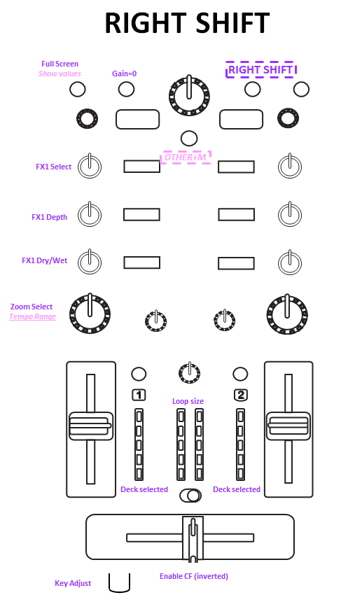

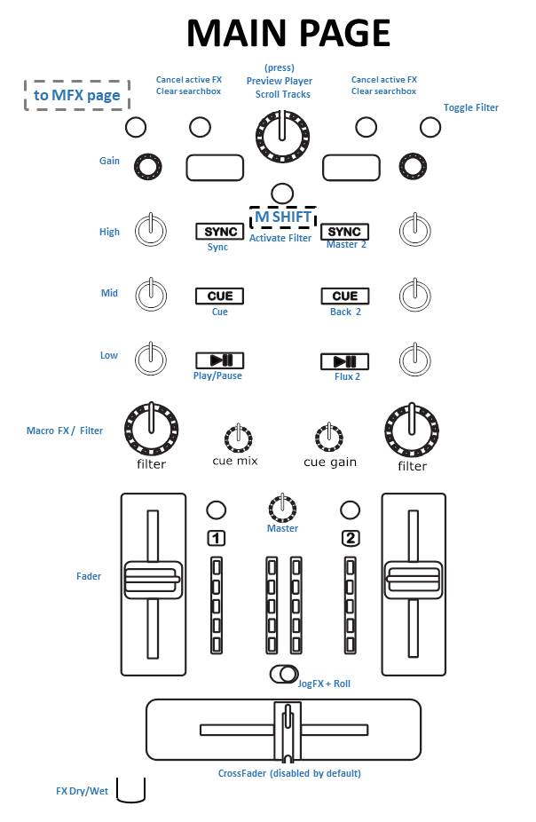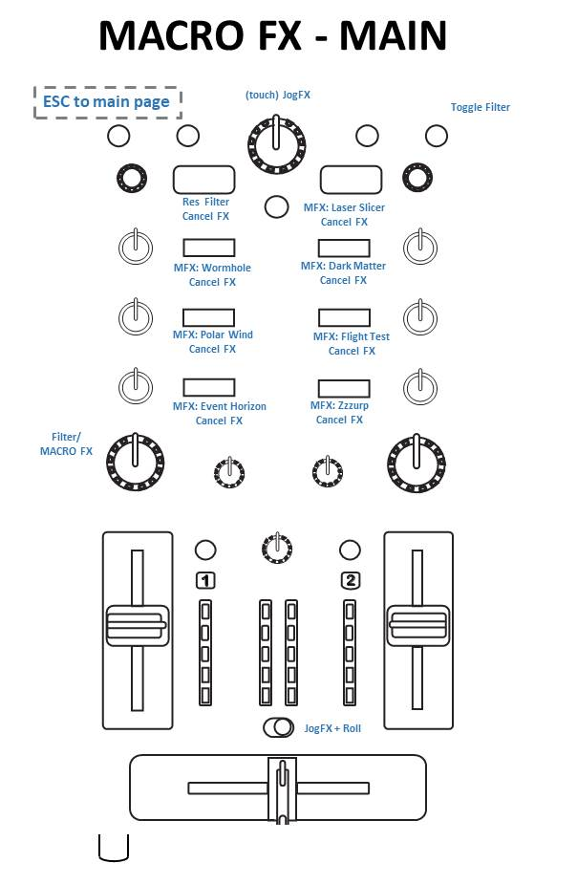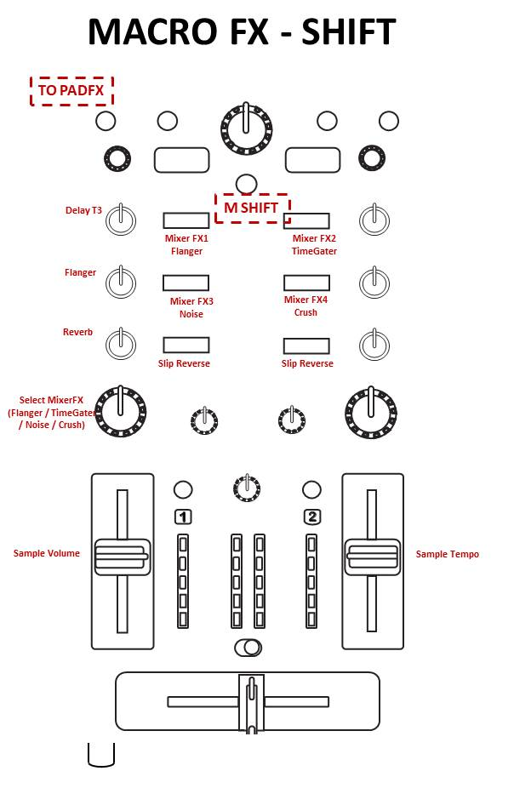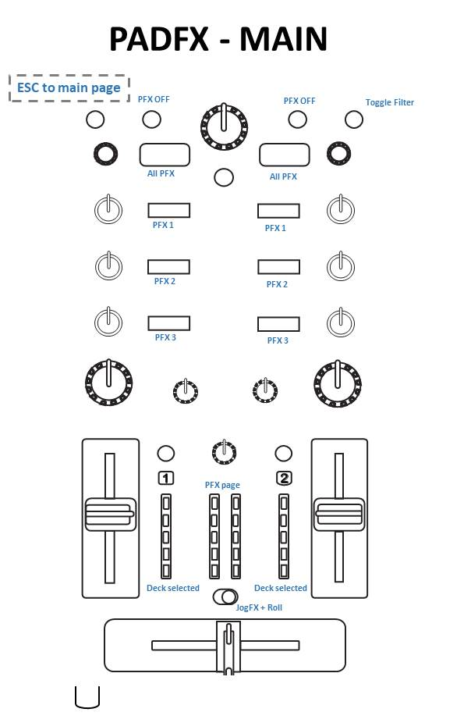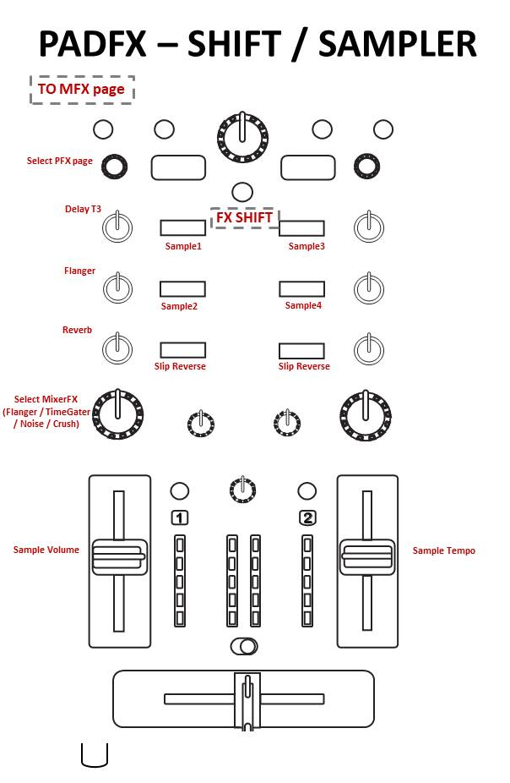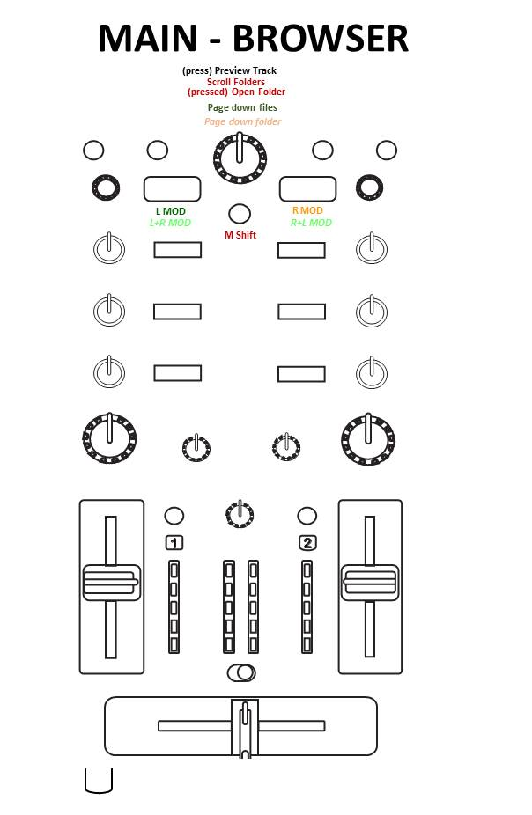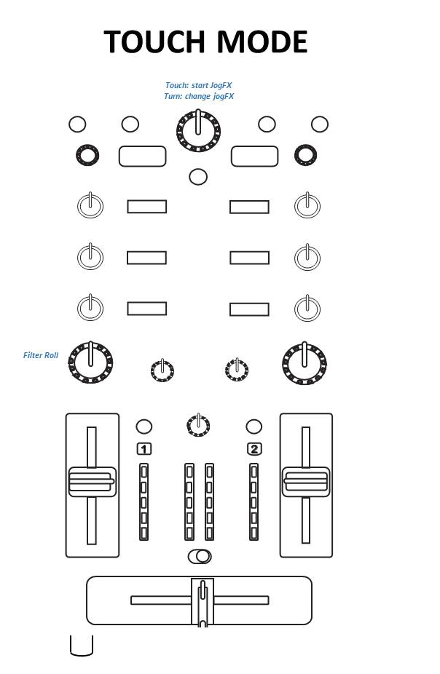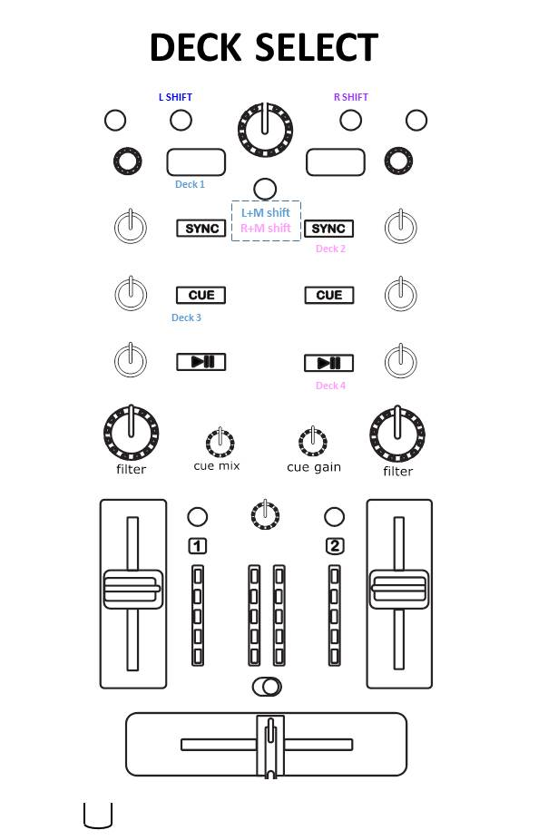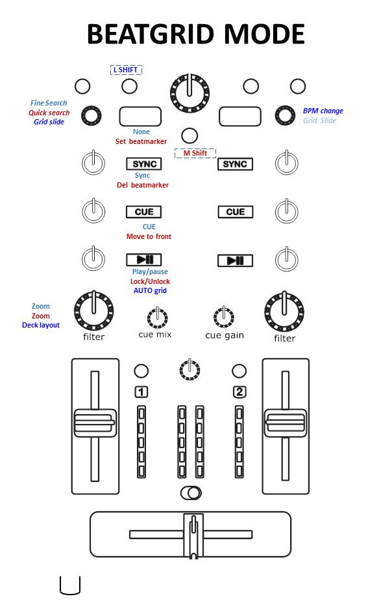

Complete reference:

|  |  |  |  |  |
| --- | --- | --- | --- | --- |
|  |  |  |  |  |
| ***note: all below assignments refer to the LEFT DECK!!*** | | |  |  |
|  |  |  |  |  |
|  | MAIN MODE |  |  |  |
|  | M1=6 | M1=1 | M1=2 | M1=4 |
| AMX name | (None) | Main shift | LEFT Shift | Left+Main |
| **PANEL** | goto MFX page | goto PFX page | Snap / Quantize | ToolTips |
| **L SEARCH** | Left shift | Left deck select / Beatgrid |  |  |
| **M Shift** | Main shift |  |  |  |
| **R SEARCH** | Right Shift | Right deck select / BeatGrid | Reset Gain | L Keylock |
| **TOUCH** | Enable Filter FX |  |  |  |
|  |  |  |  |  |
| **BROWSER Turn** | Scroll Tracks / Preview Player | Scroll Folders | BeatJump | Loop move |
| **BROWSER Press** | Preview Player | Open/Close folder |  |  |
| **BROWSER Touch** | JOG_FX |  |  |  |
|  |  |  |  |  |
| **L GAIN** | L Gain | L Quick search | Loop size | Move size |
| **R GAIN** | Danger! (other deck) | Danger! (other deck) | Tempo Bend /  Fine Search | Tempo Change |
|  |  |  |  |  |
| **L TREBLE** | Treble | FIXED FX: Delay | HOLD MFX: Select |  |
| **L MID** | Mid | FIXED FX: Flanger | HOLD MFX: Hold Value |  |
| **L BASS** | Bass | FIXED FX: Reverb |  |  |
| **L FILTER** | MixerFX / MacroFX | MixerFX select | Deck Size |  |
|  |  |  |  |  |
| **VOLUME FADER** | Volume Fader |  |  |  |
|  |  |  |  |  |
| **LOAD 1** | (L modifier) | Load Left Deck | Loop Set (4 beats) | NA |
| **LOAD 2** | (R modifier) | Danger! (other deck) | Loop Set (selected size) | Toggle Deck |
| **L SYNC** | L Sync | L Master | Hot Cue1 | Delete HC1 |
| **R SYNC** | Danger! (other deck) | Danger! (other deck) | Hot Cue2 | Delete HC2 |
| **L CUE** | L Cue | L Move to front | Hot Cue3 | Delete HC3 |
| **R CUE** | Danger! (other deck) | Danger! (other deck) | Hot Cue4 | Delete HC4 |
| **L PLAY/PAUSE** | L Play/pause | L Slip Reverse | Hot Cue5 | Delete HC5 |
| **R PLAY/PAUSE** | Danger! (other deck) | Danger! (other deck) | Hot Cue6 | Delete HC6 |
|  |  |  |  |  |
| **CUE MIX** | Cue Mix | Zoom | Balance Adjust |  |
| **CUE GAIN** | Cue Gain |  |  |  |
| **MASTER** | Master Volume |  |  |  |
|  |  |  |  |  |
| **X-FADER REV** | Enable JogFX and Roll  (requires touch!) |  |  |  |
| **CROSSFADER** | Crossfader | Disable CF | Enable CF (normal) |  |
| **CF CURVE** | Dry/Wet Master | Pan | Resonance |  |
|  |  |  |  |  |
| **VU METER 1/2** | VU deck 1 | Deck Selected | Deck Selected |  |
| **VU MASTER** | VU master | Track Position | Loop Size |  |
|  |  |  |  |  |
|  |  |  |  |  |
|  |  |  |  |  |
|  | MAIN MODE (Additonal shifts) | |  |  |
|  | M1=3 | M1=7 | M7=2 | M7=4 |
| AMX name | RIGHT Shift | Right+Main | L LOAD | R LOAD |
| **PANEL** | FullScreen | Show Values |  |  |
|  |  |  |  |  |
| **BROWSER Turn** |  |  | Page Up/Down | Favorites Select |
| **BROWSER Press** |  |  | Magnifier | Magnifier |
|  |  |  |  |  |
| **L TREBLE** | HOLD FX: SELECT |  |  |  |
| **L MID** | HOLD FX: PARAM |  |  |  |
| **L BASS** | HOLD FX: DRY/WET |  |  |  |
| **L FILTER** | Layout select | Tempo Range |  |  |
|  |  |  |  |  |
| **CROSSFADER** | Enable CF (Inverted) |  |  |  |
| **CF CURVE** | Key Adjust | CF curve |  |  |
|  |  |  |  |  |
|  |  |  |  |  |
|  |  |  |  |  |
|  | BEATGRID / DECK SELECT MODE | |  |  |
|  | M1=6 | M1=1 | M1=2 | M1=4 |
| AMX name | (None) | Main shift | LEFT Shift | Left+Main |
| **L GAIN** | L Fine search | Quick search | Grid slide |  |
| **L LOAD** |  | Set beatmarker |  | Select Deck 1 |
| **L SYNC** | Sync | Remove beatmarker |  | Select Deck 2 |
| **L CUE** | Cue | Move to front |  | Select Deck 3 |
| **L PLAY/PAUSE** | Play/Pause | Auto Grid | Lock Track | Select Deck 4 |
| **L FILTER** | MixerFX / MacroFX | MixerFX select | Deck Size | Layout select |
|  |  |  |  |  |
| **R GAIN** | Danger! (other deck) | Danger! (other deck) | BPM change | Grid slide |
| **R SYNC** | Danger! (other deck) | Danger! (other deck) |  |  |
|  |  |  |  |  |
|  |  |  |  |  |
|  |  |  |  |  |
|  | Pad FX (sub-pages) (H = Hold / T = Toogle) | |  |  |
|  | ALL (load) | FX1 | FX2 | FX3 |
| **page 1** | All instant (H) | Reverb (T) | Filter92LFO (T) | DelayT3 (T) |
| **page 2** | All instant (H) (#2 = FilterLFO) | Gater (T) | peakFilter (T) | Digital LoFI (T) |
| **page 3** | All, DRY=0 (H) | IceVerb (T) | PeakFilter (T) | ReverbT3 (T) |
| **page 4** | ReverseGrain (H) | LaserSlicer 1 (H) | LaserSlicer 2 (H) | TTFX (H) |
| **page 5** | BeatMash1 (H) | BeatMash2 (H) | BeatMash3 (H) | BeatMash4 (H) |
| **page 5 (combo)** | Hold | BeatMasher | Transpose Strech | Peak Filter |
|  |  |  |  |  |
| **Jog FX2** | All instant (H) | Beatmasher | Filter | Reverb |
|  |  |  |  |  |
|  |  |  |  |  |
|  | PADFX / SAMPLER MODE |  |  |  |
|  | M4=4 | M4=1 | M4=7 |  |
| AMX name | (None) | Main shift | LEFT/RIGHT shift |  |
| **PANEL** | goto Main page | goto MFX | Snap / Quantize |  |
| **Browser Touch** | JogFX 2 |  |  |  |
|  |  |  |  |  |
| **Gain** | Dry/wet + 3x amount control | PFX Page Select |  |  |
| **L Search** | ALL PFX Off |  |  |  |
| **R search** | ALL PFX Off |  |  |  |
|  |  |  |  |  |
| **LOAD 1** | ALL PFX (Hold) |  |  |  |
| **L SYNC** | PFX1 | Play Sample #1 | L Key Up |  |
| **L CUE** | PFX2 | Play Sample #2 | L Key Down |  |
| **L PLAY/PAUSE** | PFX3 | Slip Reverse | L Key Reset |  |
| **LOAD 2** | ALL PFX (Hold) |  |  |  |
| **R SYNC** | PFX1 | Mute all Samples | R Key Up |  |
| **R CUE** | PFX2 | Play Sample #3 | R Key Down |  |
| **R PLAY/PAUSE** | PFX3 | Slip Reverse | R Key Reset |  |
|  |  |  |  |  |
| **FILTER** | MacroFX | Zoom |  |  |
| **XFADER REV** | Enable JogFX and Roll  (requires touch!) |  |  |  |
|  |  |  |  |  |
| **FADER L** | Fader L | Sample Vol + 100% Range |  |  |
| **FADER R** | Fader R | Sample BPM + Default Gain |  |  |
|  |  |  |  |  |
| **VU METER 1/2** | VU deck 1 | Deck Selected |  |  |
| **VU MASTER** | VU master | PFX Page Select |  |  |
|  |  |  |  |  |
|  |  |  |  |  |
|  |  |  |  |  |
|  | MACRO FX MODE |  |  |  |
|  | M4=2 | M4=3 | M4=6 |  |
| AMX name | (None) | Main shift | LEFT/RIGHT shift |  |
| **PANEL** | goto Main page | goto PFX page | Snap / Quantize |  |
| **L Search** | Turn off FX1+2 |  |  |  |
| **R Search** | Turn off FX1+2 |  |  |  |
|  |  |  |  |  |
| **LOAD 1** | 0 - Resonant Filter |  |  |  |
| **L SYNC** | 1 - Laser Slicer | Mixer FX1 | L Key Up |  |
| **L CUE** | 2 - FlightTest | Mixer FX2 | L Key Down |  |
| **L PLAY/PAUSE** | 3 - Dark Matter | Slip Reverse | L Key Reset |  |
| **LOAD 2** | 4 - GranuPhase |  |  |  |
| **R SYNC** | 5 - Zzzuuurp | Mixer FX3 | R Key Up |  |
| **R CUE** | 6 - Streetch | Mixer FX4 | R Key Down |  |
| **R PLAY/PAUSE** | 7 - Bass o Matic | Slip Reverse | R Key Reset |  |
|  |  |  |  |  |
| **Browser Touch** | JogFX 2 |  |  |  |
|  |  |  |  |  |
| **Filter** | MacroFX | Zoom |  |  |
| **XFADER REV** | Enable JogFX and Roll  (requires touch!) |  |  |  |
| **VU METER 1/2** | VU deck 1 |  |  |  |
| **VU MASTER** | VU master |  |  |  |
|  |  |  |  |  |
|  |  |  |  |  |